Thorndale Dental Associates supports Caln Community Day September 13,2014
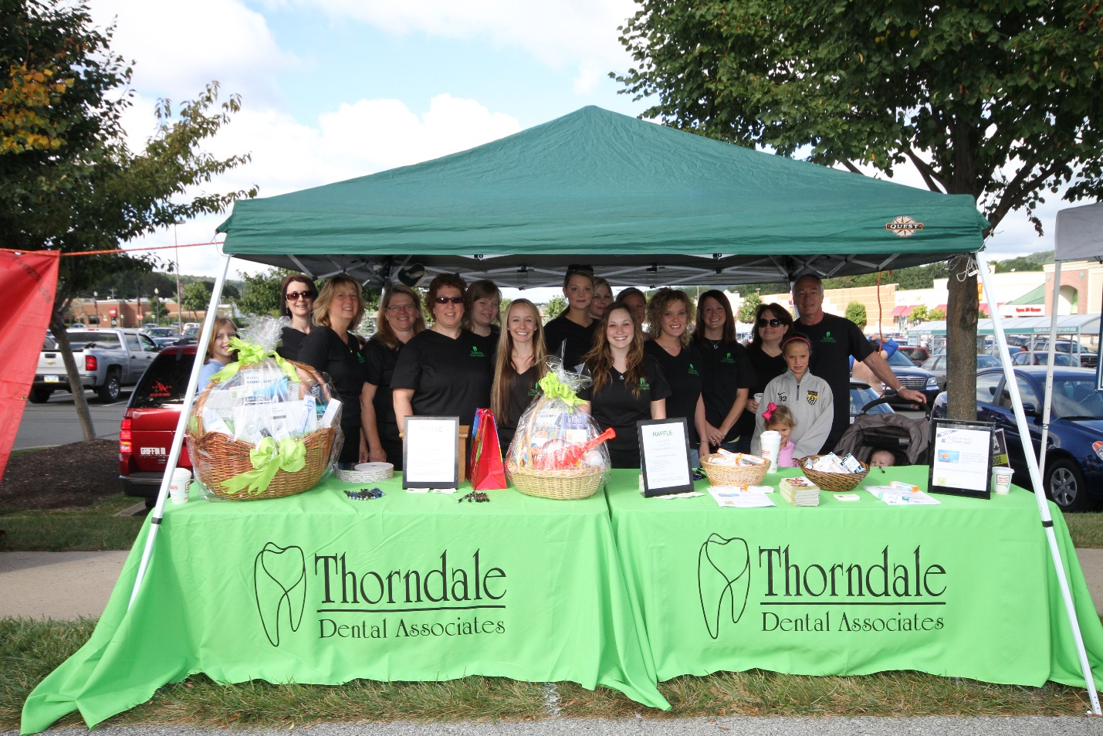
This year Dr. DeForno and staff will be donating their time and efforts to help Caln Community Days. Last year TDA raised over $1500.00 that was donated to Thorndale Volunteer Fire Company. This year TDA and our local firemen would like to reach a goal of $3000.00. Once again we will have a dunk tank where Caln Commissioners, Firemen and Dr. DeForno will be placed in the dunk tank. Last year Dr. D. was dressed as a tooth fairy…. I wonder what he will be this year! In addition we will also be raffling off two gift baskets. Some of the prizes will include a Kindle, children’s video game, and gift cards to name a few items.
Dr. DeForno grew up in the suburbs of Pittsburgh. He graduated from Kiski Area Senior High School with high honors. He was a three time letterman, competing in football, wrestling, and track and field. In 1976 he graduated from the University of Pittsburgh School of Dental Medicine. He moved to Thorndale later that same year and began practicing with a classmate in Coatesville. In 1984 he opened Thorndale Dental Associates and Thorndale Dental Arts, where he is still practicing today.
Dr. DeForno is committed to excellence in dentistry. He spends approximately 150 hours continuing his education on a yearly basis. He had the privilege to serve as the President of the Delaware Valley LD Pankey Study Club, which he is also a member. He is a member of the American Dental Association, The Pennsylvania Dental Association, the A.V. Purinton Academy; of which he is also a member of the Board, he is a member and mentor of the LD Pankey Institute, The Academy of Implant Dentistry, The Academy of General Dentistry, The Pennsylvania Academy of General Dentistry; which he is Director of the Board, and a member of the Chester-Delaware Dental Society. Dr. DeForno recently received his Fellowship with The International Congress of Oral Implantologists (ICOI).
In July 2002, he was the recipient of the most prestigious award, Mastership, in the Academy of General Dentistry. In attaining his Mastership, Dr. DeForno met the highest criteria for professional excellence by taking 1,100 hours of continuing education in the 16 disciplines of dentistry, including 400 hours dedicated to “hands-on” skills and techniques. Since 1952, only 1800 dentists have received Mastership honors worldwide.
Dr. DeForno resides in Chester Springs with his wife and our office manager Stephanie along with his step-son Ross and step-daughter Liz. His oldest son, Rich, lives in California and is a professional animator. His youngest son, Patrick graduated from the Kornberg School of Dentistry-Temple University and is currently practicing general dentistry.
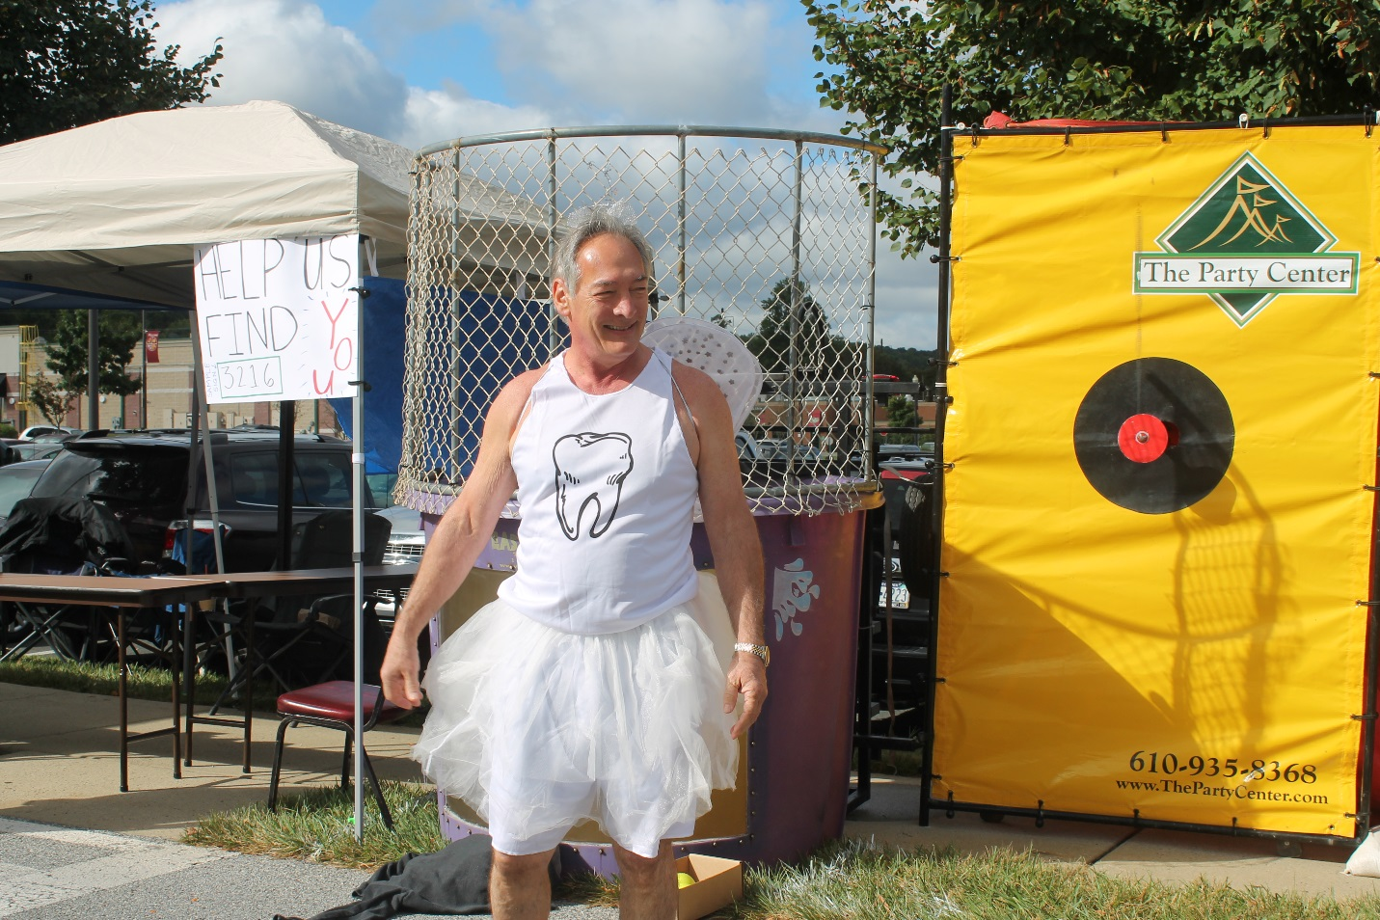

You may call or stop by the office to view the baskets or make a donation to this wonderful cause. If you have any questions please call us at (610) 384-2541
Office Location:
3105 C.G. Zinn Road
Thorndale, PA 19370

